***Name: Himanshi Kothari JU Number: JUUG22BTECH39288***

//1. Write a program to swap 2 numbers without using third variable?

#include<stdio.h> int main()

{

int a=10, b=20; printf("Before swap a=%d b=%d",a,b); a=a+b;//a=30 (10+20) b=a-b;//b=10 (30-20) a=a-b;//a=20 (30-10) printf("\nAfter swap a=%d b=%d",a,b);

return 0;

}

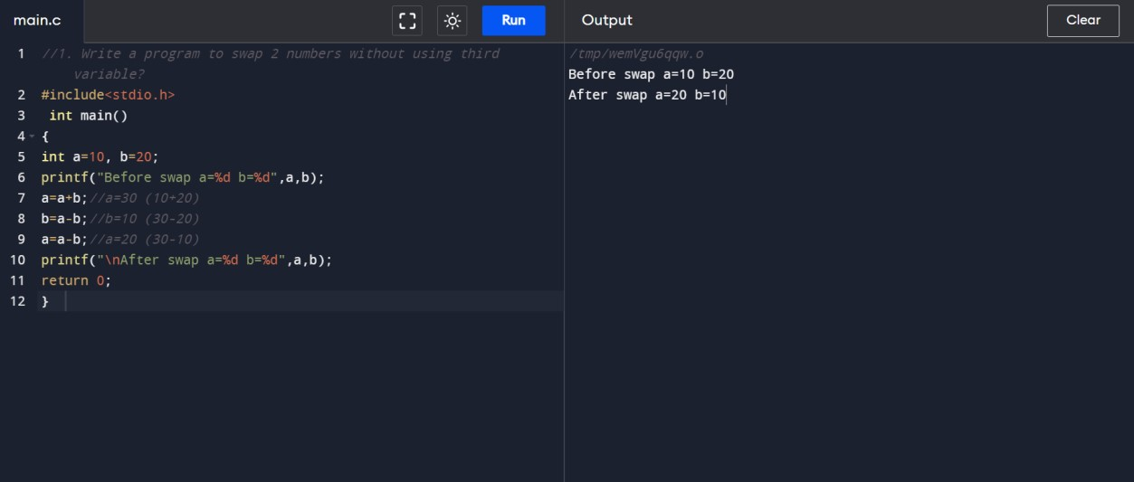

//2. Write a program to find given number is +ve or -ve number

#include<stdio.h> int main()

{ int a;

printf("Enter the Value of a :"); scanf("%d",&a);

if(a>0)

{

printf("\na is Positive");

}

else if(a==0)

{

printf("\na is Zero");

} else

{

printf("\na is Nagative");

}

}

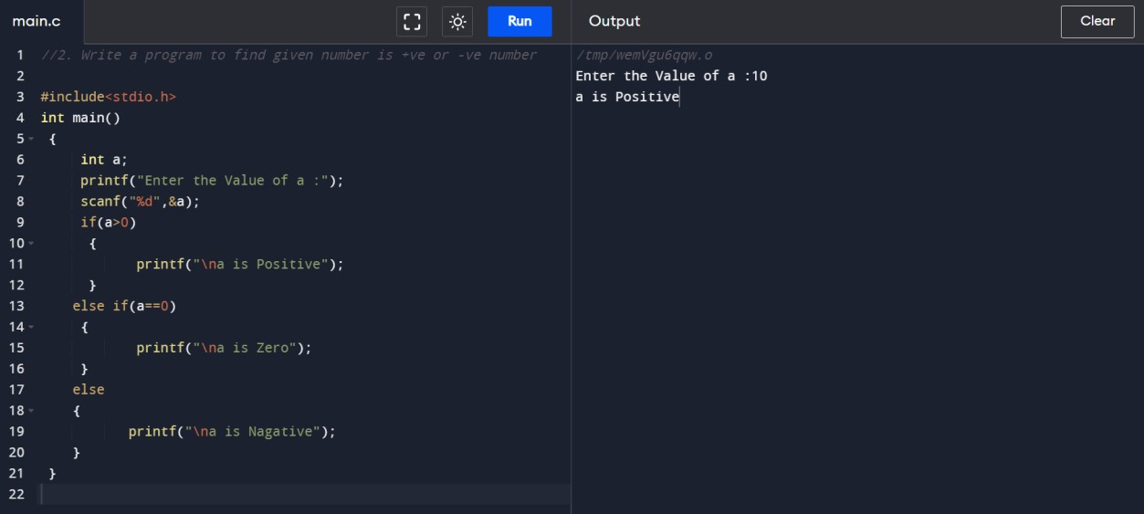

//3. Write a program to find biggest number among 3 numbers

#include <stdio.h>

int main()

{

int A; int B; int C;

printf("Enter the numbers A: ");

scanf("%d", &A); printf("Enter the numbers B: ");

scanf("%d", &B);

printf("Enter the numbers C: "); scanf("%d",&C);

if (A >= B && A >= C) printf("%d is the largest number.", A);

if (B >= A && B >= C) printf("%d is the largest number.", B);

if (C >= A && C >= B) printf("%d is the largest number.", C);

return 0;

}

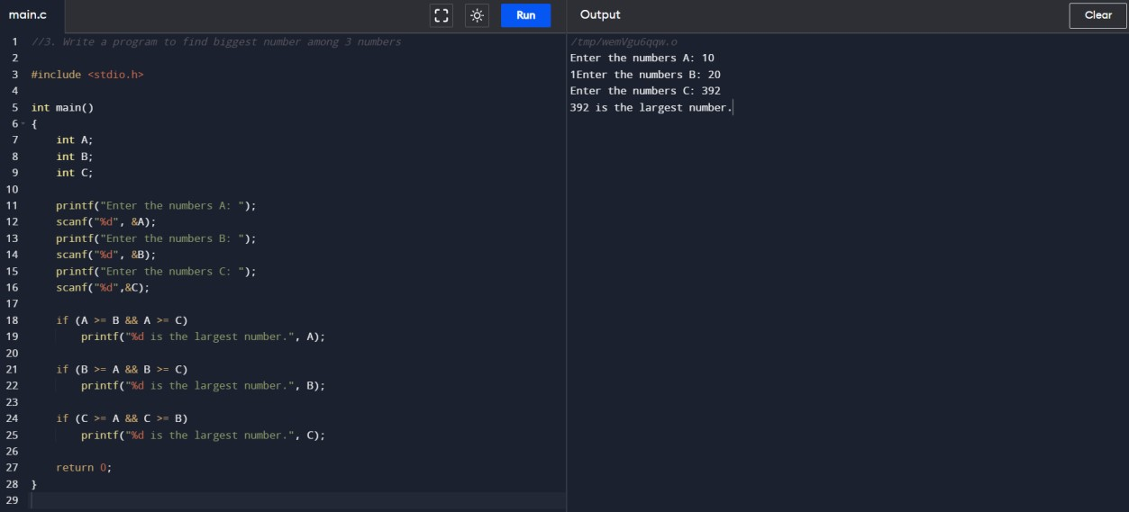

//4. Write a program to print even numbers up to 10

#include <stdio.h>

int main()

{

printf("The First 10 Even Natural Numbers are\n"); for (int i = 1; i <= 10; i++)

{

printf("%d\n", 2 * i);

}

}

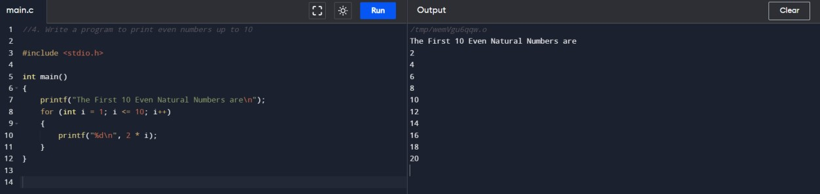

// 5. Write a program to find the sum of 1+2+3+...+10

#include<stdio.h> main()

{

int i=1,sum=0; while(i<=10)

{

sum=sum+i;

i++;

}

printf("\n Sum = %d",sum);

}

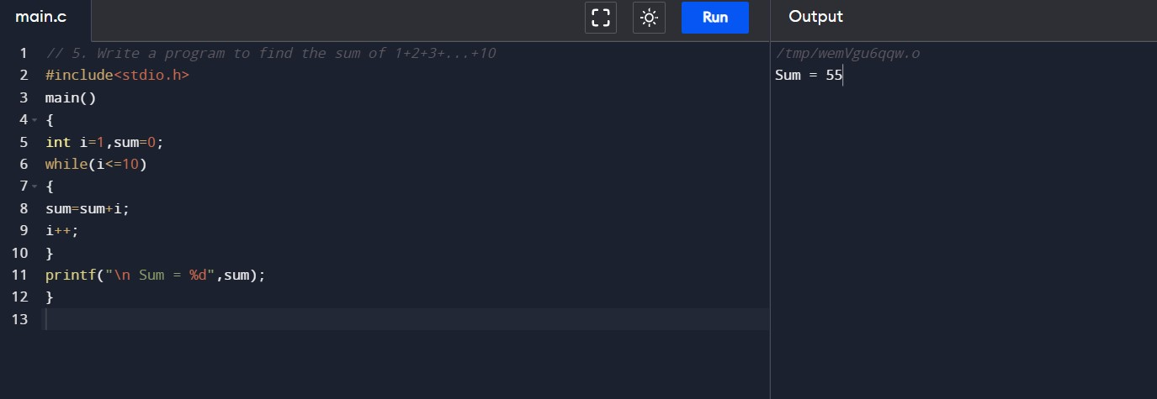

//6. Write a program to find factorial of a given number using while loop

#include<stdio.h> int main()

{

int n,f=1; printf("\n Enter a number :"); scanf("%d",&n); while(n>=1)

{

f=f*n; n--;

}

printf("\n Factorial = %d",f);

}

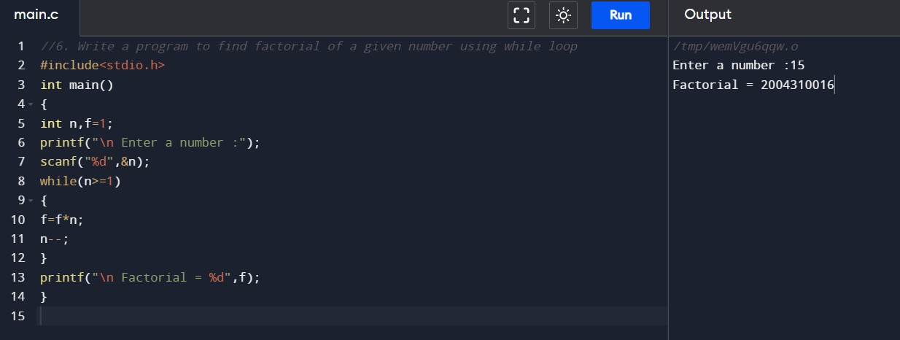

//7. Write a program to print Fibonacci series using while loop

#include<stdio.h> main()

{

int a=0,b=1,c,n; printf("\n Enter Range :"); scanf("%d",&n); printf("%d",a); printf("\t%d",b); c=a+b; while(c<=n)

{

printf("\t %d",c); a=b; b=c; c=a+b;

}

}

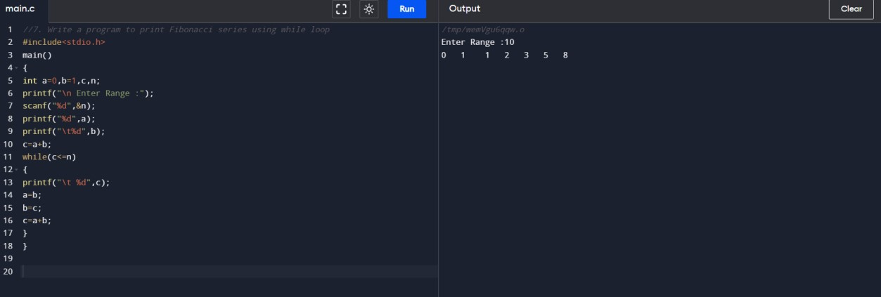

//8. Write a program to find reverse number of a given number

#include<stdio.h> main()

{

int n,rem,rev=0; printf("\n Enter a number :"); scanf("%d",&n); while(n!=0)

{

rem=n%10;

rev=(rev*10)+rem; n=n/10;

}

printf("\n Reverse number = %d",rev);

}

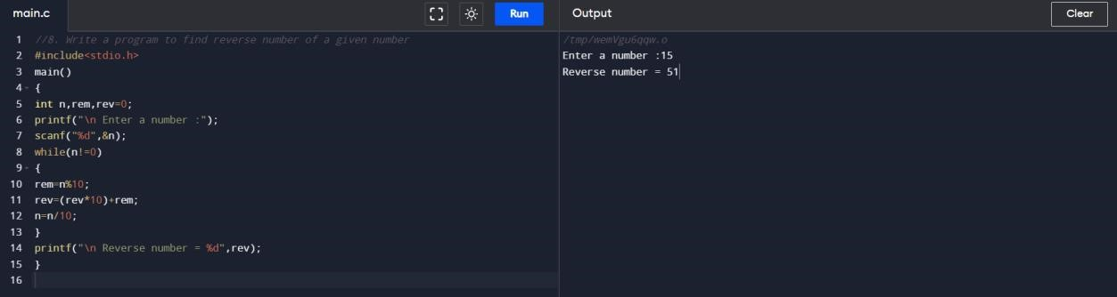

//9. Write a program to check whether given alphabet is vowel or not using switch Case

#include<stdio.h> main()

{

char ch; printf("\n Enter a character :"); scanf("%s",&ch);

switch(ch)

{

case 'a': printf("\n Vowel"); break; case 'e': printf("\n Vowel"); break; case 'A': printf("\n Vowel"); break; case 'E': printf("\n Vowel"); break; default: printf("\n Not vowel"); break;

}

}

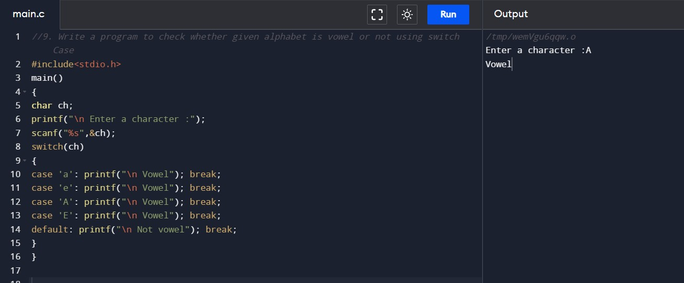

// 10. Write a program to find length of a given string

#include <stdio.h>

#include <string.h>

int main()

{

char Str[1000];

int i;

printf("Enter the String: ");

scanf("%s", Str);

for (i = 0; Str[i] != '\0'; ++i);

printf("Length of Str is : %d", i);

return 0;

}

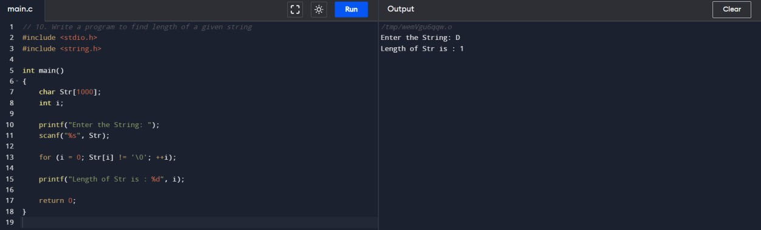

/*11. Using for loop print the following format

1

12

123

1234

12345

*/

#include<stdio.h> main()

{ int i,j;

for(i=1;i<=5;i++)

{

for(j=1;j<=i;j++) printf("%d",j); printf("\n");

}

}

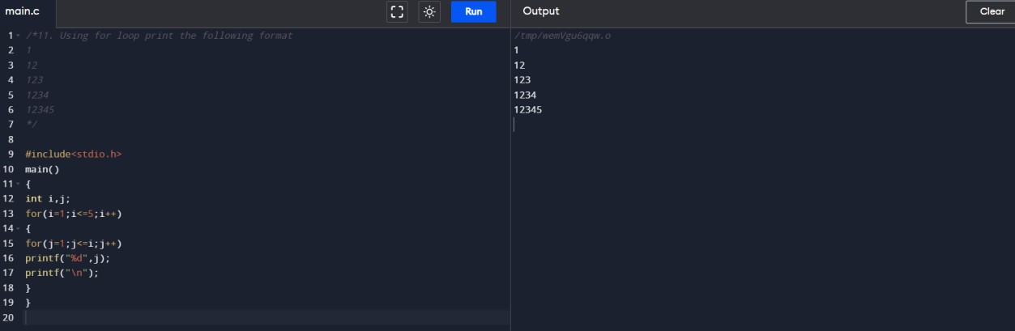

/*12. Using for loop print the following format

A

AB

ABC

ABCD

ABCDE

*/

#include<stdio.h> main()

{ int i,j;

for(i=65;i<=69;i++)

{

for(j=65;j<=i;j++) printf("%c",j); printf("\n");

}

}

